1. simple linear regression in matrix terms
a.
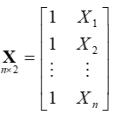
X = | 1 | 349.1
 | 1 | 351.5
 | 1 | 217.7
 | 1 | 231.8
 | 1 | 319.1
 | 1 | 414.5
 | 1 | 367.8
 | 1 | 300.2

X` = | 1 | 1 | 1 | 1 | 1 | 1 | 1 | 1
 | 349.1 | 351.5 | 217.7 | 231.8 | 319.1 | 414.5 | 367.8 | 300.2
b.
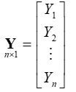
 | 300
 | 370
 | 191
Y = | 195
 | 373
 | 466.275
 | 332.5
 | 315

c.
X'X = |  | 1 | 1 | 1 | 1 | 1 | 1 | 1 | 1 | 1 | 349.1 |  | 8 | 2551.7
 |  | 349.1 | 351.5 | 217.7 | 231.8 | 319.1 | 414.5 | 367.8 | 300.2 | 1 | 351.5 | = | 2551.7 | 845579.5
 |  |  |  |  |  |  |  |  |  | 1 | 217.7
 |  |  |  |  |  |  |  |  |  | 1 | 231.8
 |  |  |  |  |  |  |  |  |  | 1 | 319.1
 |  |  |  |  |  |  |  |  |  | 1 | 414.5
 |  |  |  |  |  |  |  |  |  | 1 | 367.8
 |  |  |  |  |  |  |  |  |  | 1 | 300.2
8 | 2551.7
2551.7 | 845579.5

X`X =

X'Y = | 1 | 1 | 1 | 1 | 1 | 1 | 1 |  |  | 300 | = | 2542.775
 | 349.1 | 351.5 | 217.7 | 231.8 | 319.1 | 414.5 | 367.8 | 300.2 |  | 370 |  | 850718.5
 |  |  |  |  |  |  |  |  |  | 191
 |  |  |  |  |  |  |  |  |  | 195
 |  |  |  |  |  |  |  |  |  | 373
 |  |  |  |  |  |  |  |  |  | 466.275
 |  |  |  |  |  |  |  |  |  | 332.5
 |  |  |  |  |  |  |  |  |  | 315
2542.775
850718.5
X`Y =

3.336102 | -0.010067333
-0.01007 | 3.15627E-05
XX⁻¹ =

X*(X’X)⁻¹ ⁼
-0.178404255 | 0.000951222
-0.202565854 | 0.001026973
1.144443329 | -0.003196123
1.002493931 | -0.002751088
0.123615742 | 4.33988E-06
-0.836807846 | 0.003015426
-0.366663385 | 0.001541446
0.313888339 | -0.000592196

The Hat Matrix
X(X`X)⁻¹X` =
0.153667 | 0.15595 | 0.028677 | 0.042089 | 0.125131 | 0.215877 | 0.171455 | 0.107153
0.15595 | 0.158415 | 0.021006 | 0.035486 | 0.125141 | 0.223114 | 0.175155 | 0.105731
0.028677 | 0.021006 | 0.448647 | 0.403582 | 0.124561 | -0.18035 | -0.03109 | 0.184967
0.042089 | 0.035486 | 0.403582 | 0.364792 | 0.124622 | -0.13783 | -0.00936 | 0.176617
0.125131 | 0.125141 | 0.124561 | 0.124622 | 0.125001 | 0.125415 | 0.125212 | 0.124919
0.215877 | 0.223114 | -0.18035 | -0.13783 | 0.125415 | 0.413086 | 0.272266 | 0.068423
0.171455 | 0.175155 | -0.03109 | -0.00936 | 0.125212 | 0.272266 | 0.20028 | 0.096079
0.107153 | 0.105731 | 0.184967 | 0.176617 | 0.124919 | 0.068423 | 0.096079 | 0.136111

-81.5103
1.252051
β = (X`X)⁻¹(X`Y)
3.336102 | -0.010067333
0.01007 | 3.15627E-05
2542.775
850718.5
=
d.
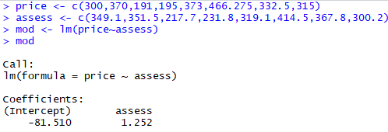
The regression model; price = -81.51 + 1.252*assess

e.
H2,3 = 0.021006
2. Multiple linear regression
a.
X = |  | 1 | 349.1 | 6126
 |  | 1 | 351.5 | 9903
 |  | 1 | 217.7 | 5200
 |  | 1 | 231.8 | 4600
 |  | 1 | 319.1 | 6095
 |  | 1 | 414.5 | 8566
 |  | 1 | 367.8 | 9000
 |  | 1 | 300.2 | 6210

b.
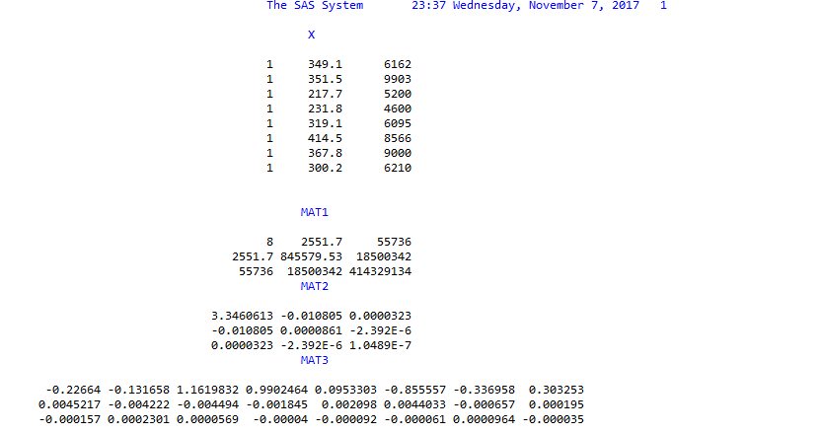

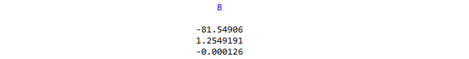

c.
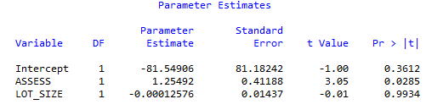

d.

dm "out; clear; log; clear";

Data BaseJr; /* Creates SAS dataset named BaseJr */
Input PRICE ASSESS LOT_SIZE; /* Inputs a subset, n=8, of Baseball Data */
Datalines;
300 349.1 6162
370 351.5 9903
191 217.7 5200
195 231.8 4600
373 319.1 6095
466.275 414.5 8566
332.5 367.8 9000
315 300.2 6210
;

Proc IML; /* Opens the Matrix Language procedure */
use BaseJr; /* Identifies the SAS file to import */
read all; /* Imports all components of SAS dataset
BaseJr with their names! */

one_vec = j(8,1); /* "j(n,1)" creates a vector of length n
filled with 1's. */

X = one_vec || ASSESS || LOT_SIZE; /* "||" sandwiches columns into a matrix */
print X;

Y = PRICE;

mat1 = t(X) * X; /* */
mat2= inv(t(X) * X);
mat3 = inv(t(X) * X) * t(X);
print mat1, mat2, mat3;

b = inv(t(X) * X) * (t(X)*Y); /* computes b vector in one go! */
print b;

run;

Proc Reg; /*gets the slope coefficients for comparison*/
Model Won_2010 = Won_2009 RS_2009;
run;

